SemFeel: A User Interface with Semantic Tactile Feedback for Mobile Touch-screen Devices

【Main Content】:

Place motors in different locations of the device to produce different tactile effects

【SemFeel】：

SemFeel has five vibration motors embedded in different locations on the back of the mobile touch screen device (especially the top, bottom, right, left and center of the device)

11 vibration modes

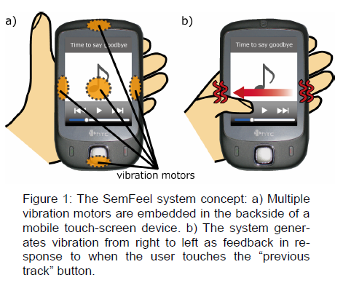

【Experiments】：

**Experiment 1:DISTINGUISHABILITY OF PATTERNS**

In this experiment, we asked the participants to determine which of the eleven vibration patterns shown in Figure 4 was being generated by the system at a time (each time, the pattern was generated only once).

**Procedure：**The participants were given the explanation of the system and instructed to hold the prototype mobile device with their non-dominant hand and to use a mouse with their do-minant hand to interact with the application on the com-puter. They were then asked to perform a practice set that used the same tasks as the test sessions. They could con-tinue to practice until they felt comfortable with the tasks and system. On the average, the participants practiced for about five minutes. After each block, the participants were allowed to take a short break. In total, the entire experiment took about 45 minutes.

**Results：**Our experimental results show that despite the short number of exercises, participants can still distinguish between 11 modes, except that the accuracy in the counterclockwise direction is 83.3-93.3% (average 89.6%).

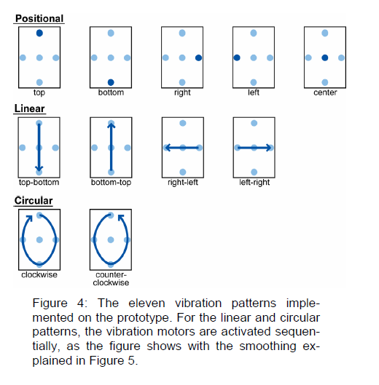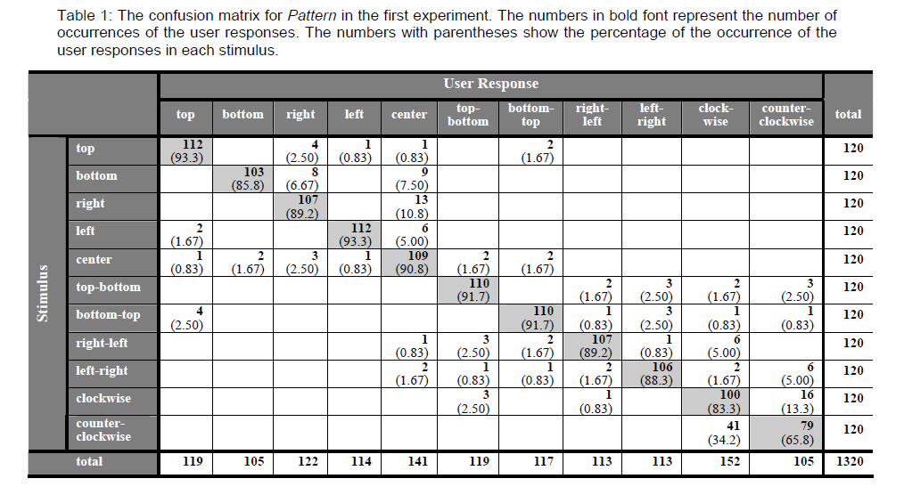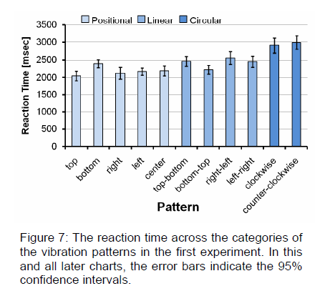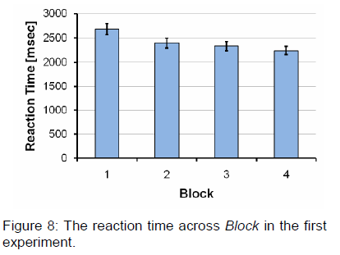

**Experiment 2:USER PERFORMANCE ON INPUT TASKS**

We designed the second experiment to examine user perform-ance in a realistic application with the SemFeel technology. In particular, we wanted to compare the accuracy of user input when using the SemFeel prototype against user inter-faces that offer no tactile feedback or tactile feedback using only a single vibration source.

**Procedure：**First, the system showed participants a four-digit number in blue on the computer screen (right of Figure 9). Next, we asked participants to type the number on the mobile touch screen device using the numeric keypad shown on the left side of Figure 9. Participants can type by releasing their thumbs from the screen, and the numbers entered will appear on the computer screen (right of Figure 9). When the participant releases their thumb outside of any key, the character "X" is displayed. This experiment studied three haptic feedback conditions: none (no haptic), haptic feedback provided by a single vibration motor (single haptic) and haptic feedback provided by SemFeel technology (or haptic feedback provided by multiple vibration modes). We Call it "multi-touch."

**Results：**Our second experiment showed that SemFeel can support more accurate with numeric keyboard applications compared to a user interface without any haptic feedback and a user interface with a single vibration source that has haptic feedback in an eyeless setting. Interaction. In addition, participants can learn vibration patterns under multi-tactile conditions in a short period of time. Our second study also showed that user interfaces with haptic feedback are slower than user interfaces without haptic feedback. This is what we expect, because participants often adjust their touch points on the screen based on haptic feedback to press the correct key. However, participants cannot make such adjustments without haptic feedback.

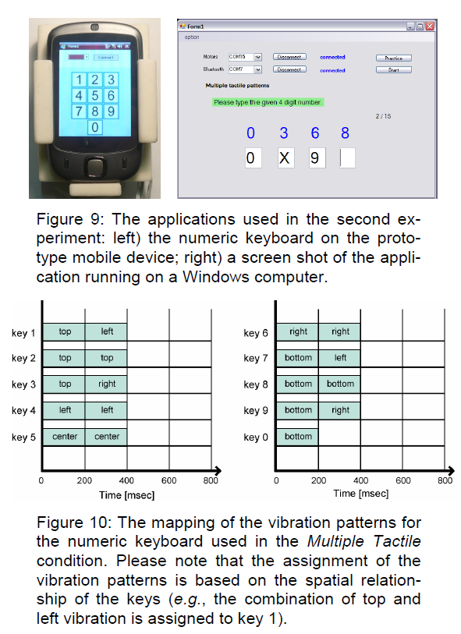 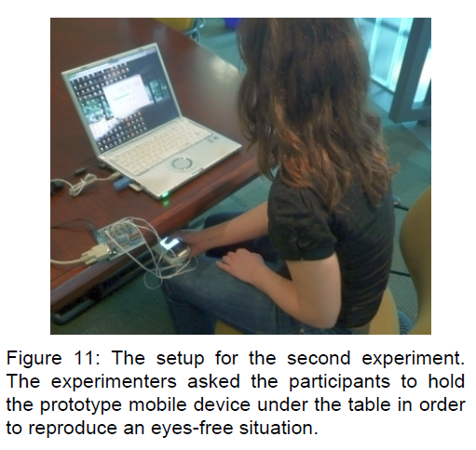

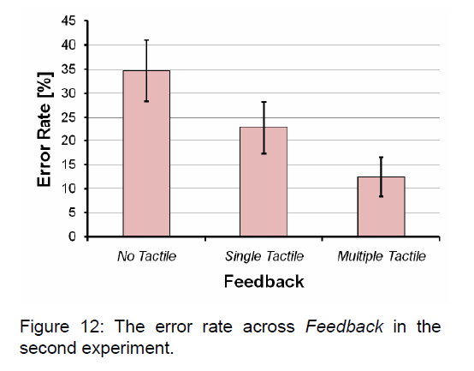 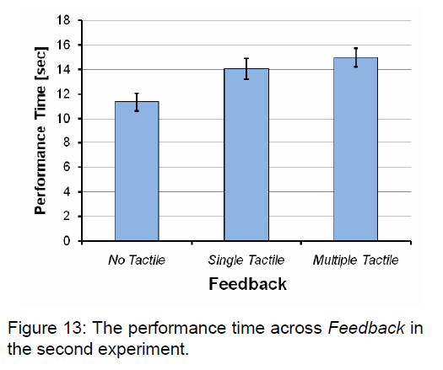

【APPLICATIONS】：

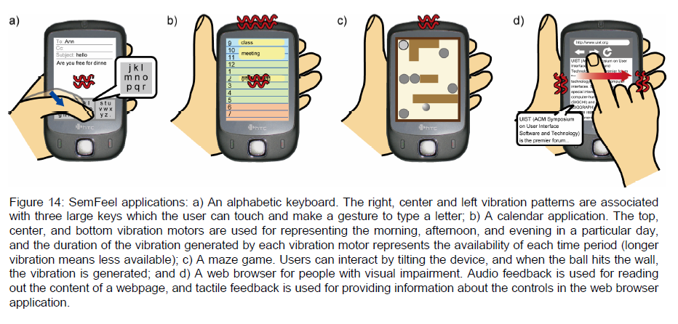

【Important Refrence】:

7. Hall, M., Hoggan, E., and Brewster, S. T-Bars: towards tactile user interfaces for mobile touchscreens. In Pro-ceedings of MobileHCI, 2008, pp. 411-414.

8. Hoggan, E., Brewster, S.A., and Johnston, J. Investigat-ing the effectiveness of tactile feedback for mobile touch-screens. In Proceeding of CHI, ACM, 2008, pp. 1573-1582.

10. Hoggan, E., Sohail, A., and Brewster, S.A. Mobile multi-actuator tactile displays. In Proceedings of the 2nd Inter-national Workshop on Haptic and Audio Interaction De-sign, Springer, 2007, pp. 22-33.

15. Oulasvirta, A., Tamminen, S., Roto, V., and Kuorelahti,J. Interaction in 4-second bursts: the fragmented nature of attentional resources in mobile HCI. In Proceedings of CHI,ACM, 2005, pp. 919-928.

17. Poupyrev, I., Maruyama, S., and Rekimoto, J. Ambient touch: designing tactile interfaces for handheld devices. In Proceedings of UIST, ACM, 2002, pp. 51-60.

18. Rantala, J., Raisamo, R., Lylykangas, J., Surakka, V., Raisamo, J. Salminen, K., Pakkanen, T., and Hippula, A. Methods for presenting braille characters on a mobile de-vice with a touchscreen and tactile feedback. IEEE Trans. on Haptics, 2, 1 (2009), 28-39.

22. Zhao, S., Dragicevic, P., Chignell, M., Balakrishnan, R., and Baudisch, P. Earpod: eyes-free menu selection using touch input and reactive audio feedback. In Proceedings of CHI, ACM, 2007, pp. 1395-1404.